Profitbase AS

Profitbase Planner
Configuration and Operation
Account module
Profitbase

26.05.2025

Version 3.5



Content

Content 2
1 Abstract, intended audience and pre-requisites 4
2 Common functionality 4
3 Principle of operation 6
Plan by year-totals or by month 6
Dimensionality 7
Change dimensionality of an input row 7
Historical references and deviation calculations 8
Planning horizon 8
Plan roll forward actions 9
4 Module configuration 9
Publish and name module, control row context right-click menu options 9
Select additional dimensionality 9
Select, name, and define historical reference columns 11
Select, name, and define deviation columns 11
Select / unselect optional columns 13
Translations 13
Attach module to input report 13
Period filters 14
Disabling the Periods button 14
5 Module settings 15
Distribution keys 15
Distribution key helper 16
Override distribution using historic data 16
Auto transactions (optional) 17
6. High level planning with the account module 18

Date: | Version: | Changed by: | Changes:
29.05.2020 | 0.0 | TN | Initial content
12.10.2020 | 1.0 | TN | Revised
19.05.2021 | 2.0 | TN | Revised for Planner v5
18.08.2021 | 2.1 | TN | Revised for Planner v5
04.10.2021 | 2.2 | TN | Revised for Planner v5 final
07.07.2022 | 3.0 | TN | Revised for Planner v5.2
05.12.2022 | 3.1 | TN | Revised for Planner v5.2.4
24.02.2023 | 3.2 | TN | Revised for Planner v5.4.0
24.06.2023 | 3.4 | TN | Revised for Planner v5.4.1
26.05.2025 | 3.5 | TN | Revised for Planner 6.1.0

Abstract, intended audience and pre-requisites

The Profitbase Planner Configuration and Operation series consist of several documents dealing with the configuration and operation of individual Planner modules and functions.

Planner modules are operational input modules that contributors to the plan processes use to prepare the Profit & Loss (P&L) of their respective areas of responsibility. Different modules will typically cover parts of the P&L such as sales, personnel, cost, etc.

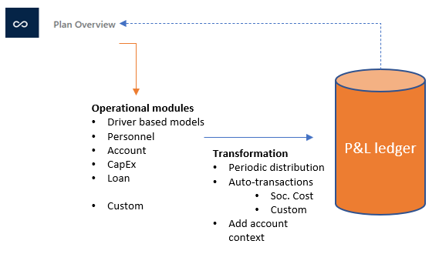

The modules are accessed from the Plan overview workbook of a given version and the input provided by the contributors are transformed into P&L transactions and fed back to the Plan overview workbook resulting in a P&L work-in-progress overview.

The intended audience of this document is implementation partners configuring the solution initially and solution administrators responsible for operating it thereafter.

This document assumes that a Profitbase Planner solution has been deployed and that access to this solution is given to the reader.

Common functionality

Changes made to input sheets are not saved automatically. To save changes, click the “Save” button. The “Save” button will remain disabled until a change has been made.

To undo all unsaved changes, click the “Refresh” button.

To undo the last of a series of unsaved changes, click the Ctrl and Z keys simultaneously.

To insert new rows to an input sheet, right-click in the sheet and select one of the available options:

- Insert row
- Insert row below
- Insert copy of row

To delete a row from an input sheet, right-click the row in question and select:

- Delete row

Inserting and deleting rows can be controlled as part of the configuration, see Publish and name module, control row context right-click menu options.

Please note, that although the row is no longer visible in the input sheet, the change must be committed using the “Save” button or undone using the “Refresh” button.

In input sheets, editable fields are distinguished from non-editable fields by fill color, editable fields have by default a white fill color.

In setting tables, a so-called ranked input concept is often used for the dimensional context. Ranked input allows for a high-level selection of dimensional nodes and gives the opportunity to alter the rank or specificity between rows.

A ranked input cell can be set through the ranked input selector by clicking the cell value (cell will display 3 dots if no value is set):

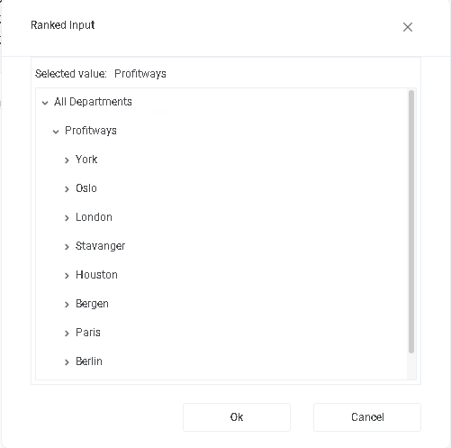

The ranked input selector will display the dimensional hierarchy and allows for the selection of a high-level dimensional node. The selection of a high-level node implies that the setting applies to all sub-ordinate nodes.

Select node and click “OK”.

Click “Cancel” to leave the selector without selecting.

In a table containing multiple rows, the rank or specificity of individual rows can be altered by moving the row up (decrease specificity) or down (increase specificity) by right-click the row in question and selecting:

- Move up
- Move down

The less specific the setting is, row should be high up in the table. The more specific the setting is, the further down in the table the row should reside.

Principle of operation

Plan by year-totals or by month
The plan can be input as year-totals or as monthly values. This is controlled by the “Periods” button that toggles the input mode correspondingly:

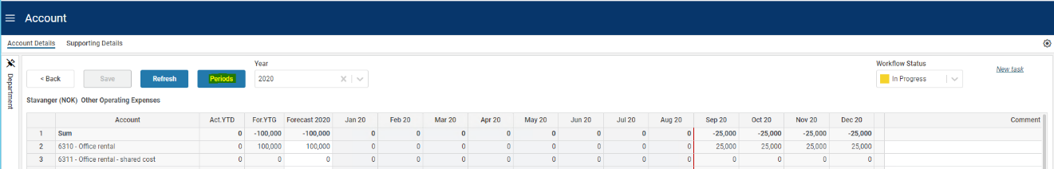

A year-total input is automatically spread to the plan months of that particular year. The total is spread according to the monthly distribution function tied to the account as follows:

- If a specific monthly input has been made by the user, the distribution inherent in the monthly values is used as a distribution key.
- If not, then if a central distribution key is tied to the account, this distribution will be used

The existence of a central distribution key is indicated by the following symbol:

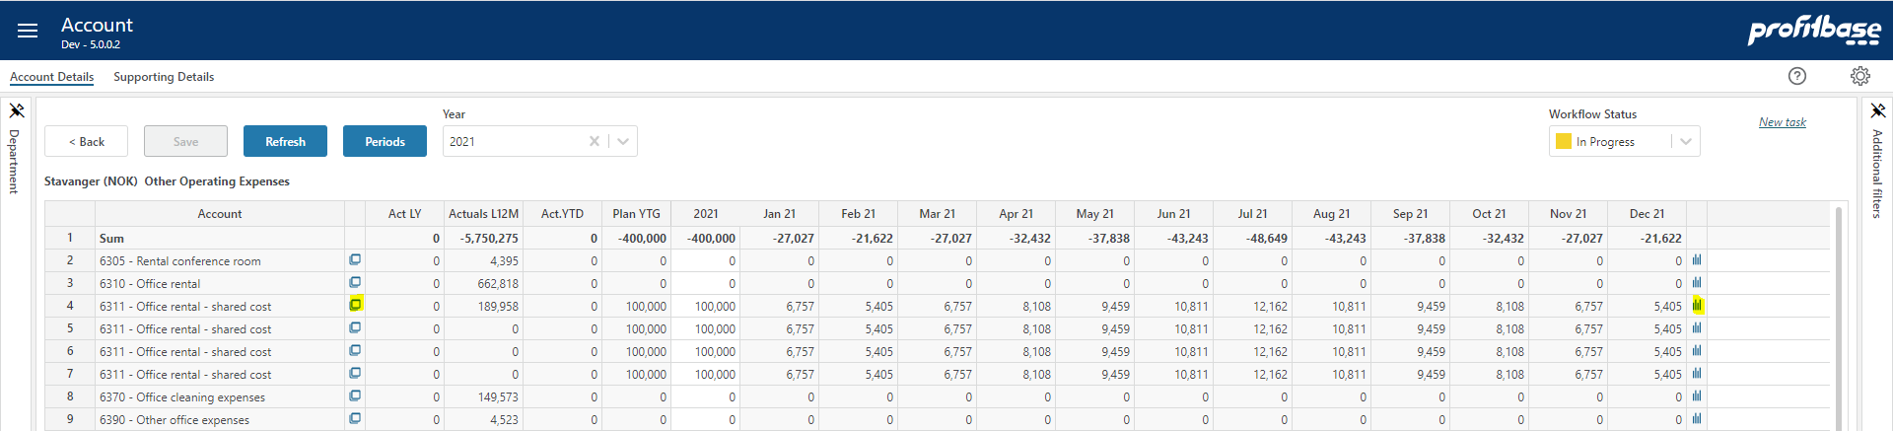

Click on the symbol to view the distribution key.

Please refer to Distribution keys for details on how to set up central distribution keys.

- If none of the above applies, the total is spread evenly over the plan months

If monthly values are input directly, the individual monthly values in a year are summed and the distribution used thereafter for year-total input will be the distribution inherent in those individual monthly values as edited by the user.

Note that you can also see the distribution of any historical and plan sets, by clicking the symbol. The result is displayed in a pop-up where you can toggle between % and absolute numbers:

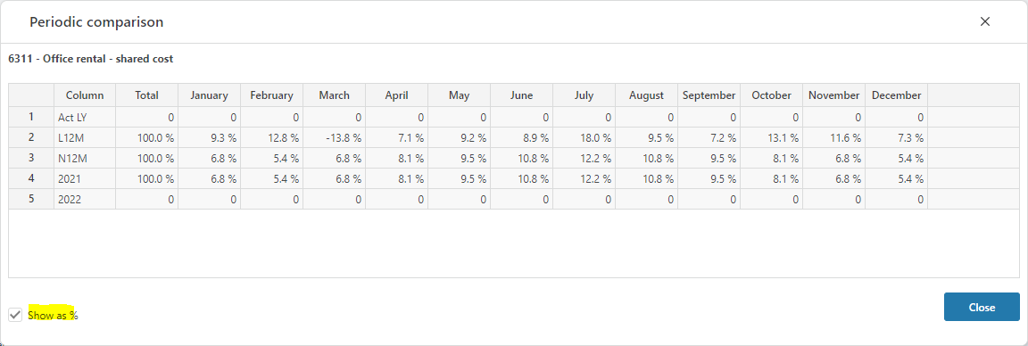

Note that you can also restore the default distribution for any row or collection of rows by right clicking the following column and select “Restore default key”. This can either be done on a specific row or on the upper-most total-row to be able to select multiple rows:

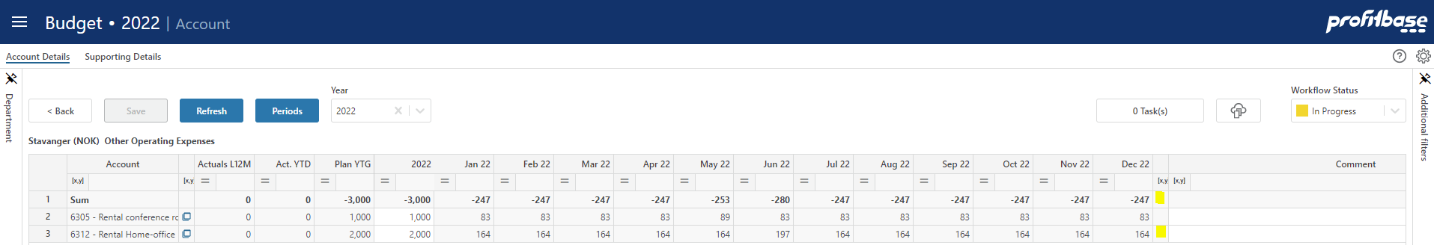

Selecting “Restore default key” on the upper-most total-row, presents a pop-up where a selection of rows can be done. Only the rows eligible for restoring the default key i.e., rows where the user has overridden the key, are shown:

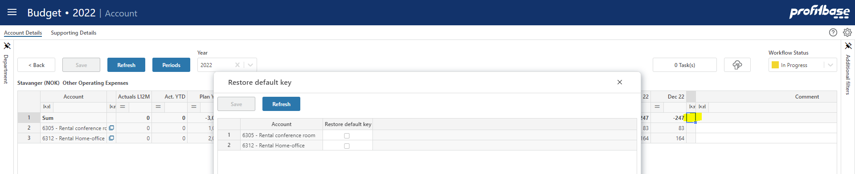

Dimensionality
The basic dimensionality of the account module is department and account.

Extra dimensionality, Project, Activity, Counterpart and 4 free dimensions Dim1, Dim2, Dim3 or Dim4 may be added as needed.

The account module can also be set up for planning in multiple currencies by enabling the Currency foreign dimension.

Please refer to Select additional dimensionality for details.

Change dimensionality of an input row

The current dimensionality of an existing input row may be changed (subject to the configuration, see Publish and name module, control row context right-click menu options) by right-clicking the row in one of the dimensional columns and selecting “Change dimensionality”. This will reveal a pop-up in which a new dimensionality can be set:
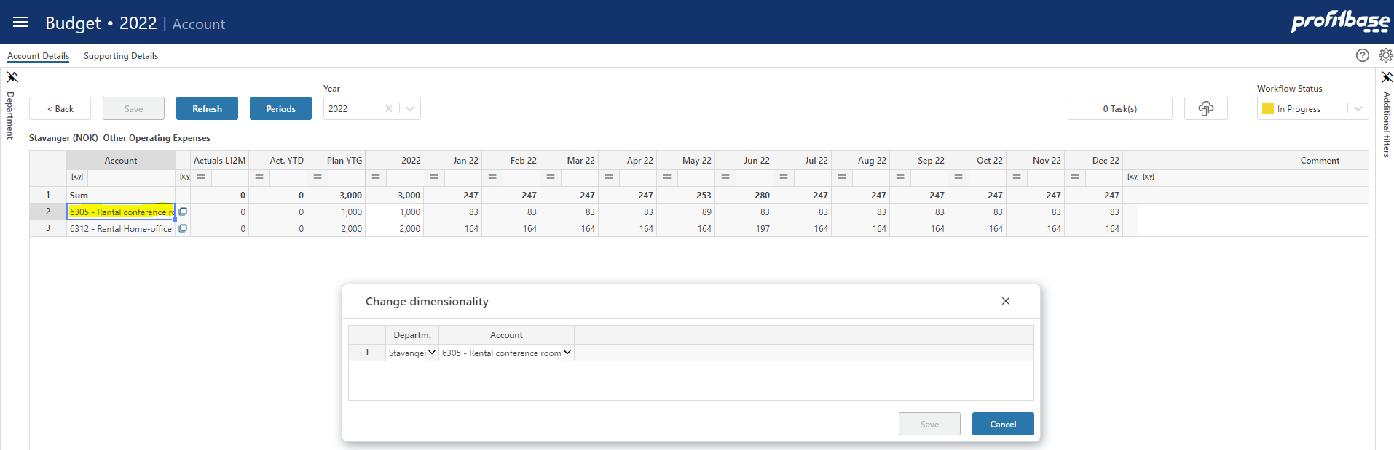

Historical references and deviation calculations
The Account module is preset with the last 12 months of actuals, except if the following base setting is set to FALSE:

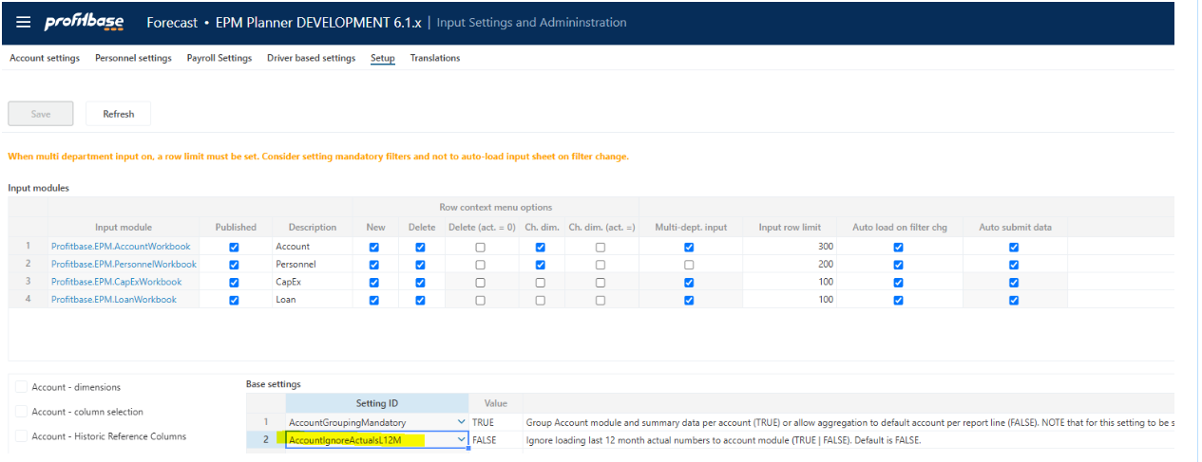

Base setting AccountIgnoreActualsL12M (TRUE | FALSE), default FALSE controls if actuals last 12 months are loaded or not to the account module.

In addition to the above, up to 5 historic reference columns (e.g. last year’s budget) may be added as needed. Please refer to Select, name, and define historical reference columns for details.

Simple deviation calculations – columns that perform calculations between other columns present in the input sheet (e.g. deviation between next year’s budget and this year’s budget) - may be added. Please refer to Select, name, and define deviation columns for details.

Planning horizon

The planning time horizon is controlled in the Finance Settings workbook:

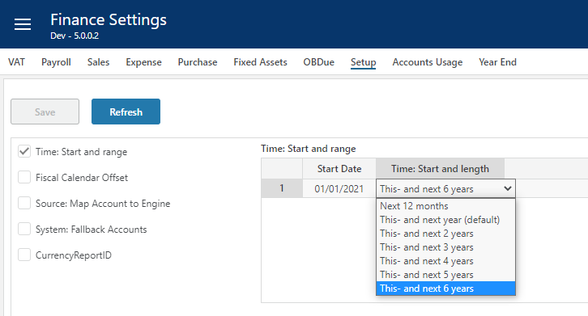

This time horizon applies to all input modules.

Long-term planning (beyond this year and next year) allows for a year-total input only. When saving the plan, the long-term year-totals are automatically distributed to months using the distribution that is relevant to the next year’s plan for the corresponding dimensionality.

Note that there is also a period filter setting that you may want to consider if you change the plan horizon. The period filter setting control which period filter will be available and which one will be the default, please refer to Period filters.

Plan roll forward actions

If long-term planning is used, the year-total for next-year+1 will be automatically distributed to monthly values using next-year’s distribution when rolling over to a new year.

Module configuration

Publish and name module, control row context right-click menu options
Select the “Input Settings and Administration” workbook and go to the “Setup” page, and edit the “Input modules” table:

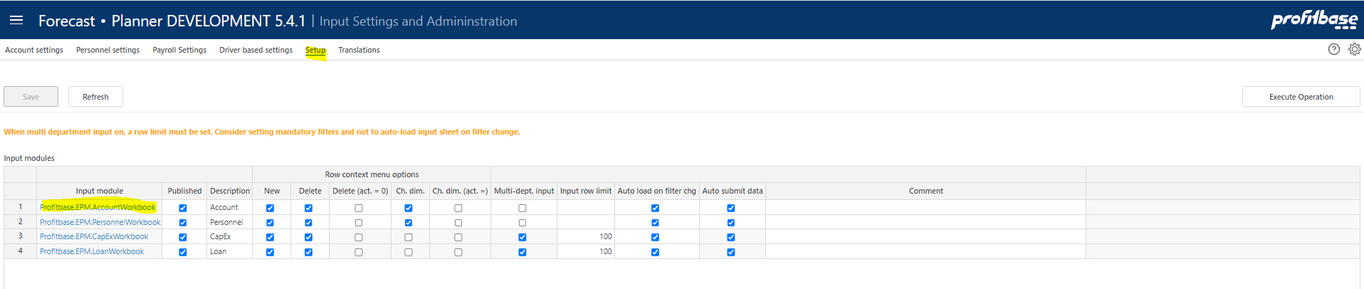

Column | Description
Input module | The name of the input module. The Input module column is an action link that will open the module in admin mode that means that changes are possible regardless of the “Published” column setting.
Published | Indicates that the input module is Published or not (checked | unchecked). If not published (unchecked), changes will not be possible unless opening the input module using the action link in the “Input module” column.
Description | The module’s default name. Translations can be added in the Translations tab.
Row context menu options (right-click)
New | Insert new row and Insert copy of row is allowed (true) or not allowed (false). Default is true.
Delete | Delete row is allowed (true) or not allowed (false). Default is true.
Delete (act. = 0) | Delete row is allowed only if row contains no actuals (true). Available for selection only if “Delete” is true.
Ch. dim. | Change dimensionality is allowed (true) or not allowed (false). Default is true.
Ch. dim. (act. = 0) | Change dimensionality is allowed only if row contains no actuals (true). Available for selection only if “Ch. dim.” is true.
Multi-dept. input | Input only allowed at lowest department level input is the default (false). If set to true, input can (given that access control allows) be given at higher-level nodes of the department dimension.  NOTE: when multi-department input is no (true), other filter should be used to narrow down the data set operated on.
Input row limit | Max. row limit returned that allows input. If row limit is reached, data is limited, and a warning is given to say that data set must be narrowed down to allow input. When multi-department input is set to true, a row limit must be set.
Auto load on filter chg. | By default, data is loaded automatically on filter change (true). When multi-department input is used, it may be desirable to first set all filters and then load the data. If this is the case, set this option to false. End user will have to use the Refresh button to load data.
Auto submit data | By default, data is submitted (i.e. processed through to the Plan Overview) once saving the data. By unchecking this option, a Submit button is displayed and the Save action will only save the input data and a manual click on the Submit button is required to actually submit the data through to the Plan Overview.

Select additional dimensionality
Select the “Input Settings and Administration” workbook and go to the “Setup” page:

There is a preset number of additional dimensions to choose from.

Column | Description
Dimension Column | The internal dimension column (preset).
Visible | Indicates that the column is visible and editable in the input worksheet or not (checked | unchecked)
Mandatory | Indicates that the column is mandatory in the input worksheet, i.e. that when inserting a new row, the user will have to select a value from the attached drop-down list.
Visible as filter (Input module) | Some of the dimensions are available for selection as input filters (slicers). Indicates whether dimension is also an input filter (checked) or not (unchecked).
Filter selection mandatory | Indicates whether it is mandatory to set a value for the filter (checked) or not (unchecked)
Default filter value | Allows for a default value for the filter to be set. This can be a leaf level value or an aggregate level value. Editable only if dimension is visible and is used as a filter. Note that this is a default filter value, implying that if the model is started from the plan overview with a specific filter value set, the default will not apply.
Group Source Data | Source data for the account module is the ledger historical facts. Opting to group source data by a certain visible dimension implies all variations in that dimension within the historical reference period (actuals last 12 months + any historical reference columns used) will be reflected in the input sheet.  For example if Dim1 had values A, B, C and D for Account X and Department Y historically and one chooses to make it visible and to group source data based on Dim1, the input sheet for department Y will 4 input line for account X in combination with Dim1 A, B, C and D with any historical values specified per Dim1.  Opting not to group source data by Dim1 in this case would imply 1 input line for Account X with Dim1 having the default value (none) and any historical values summed.  This attribute may also be useful for high-level planning where one does not want to plan per account or even per department. Please refer to High level planning with the account module for details on high level planning with the account module.
Visible as filter (plan overview) | Some of the dimensions are available for selection as filters in plan overview. Indicates whether dimension is also a plan overview filter (checked) or not (unchecked).
Sorting | Optional sorting of dimensional data. May be useful when using many dimensions. If not filled out a default sorting of dimensional data is used. Accept integer values (1,2,3..)
Comment | Optional comment.

Note that the Currency foreign dimension is always mandatory, but you can control the visibility. By default, it is hidden meaning that the plan is in the home currency of the individual legal entity. If visible, the summary row of the input sheet is disabled.

Note on CPLegalEntityID (counterparty): this dimension is available in all modules, but it is only the Sales (IC) and Loans (IC) financial engines that creates counter transactions. Providing counterparty information to transactions that are not handled by the mentioned financial engines will NOT have it’s counter transactions automatically posted. Hence, when enabling this dimension, make sure that is understood by the client. Accounts piped through the Sales (IC) engine are set up in the Finance Settings workbook and the Account to engine mapping configuration.

Select, name, and define historical reference columns

Select the “Input Settings and Administration” workbook and go to the “Setup” page and select the “Account – Historic Reference Columns” table:

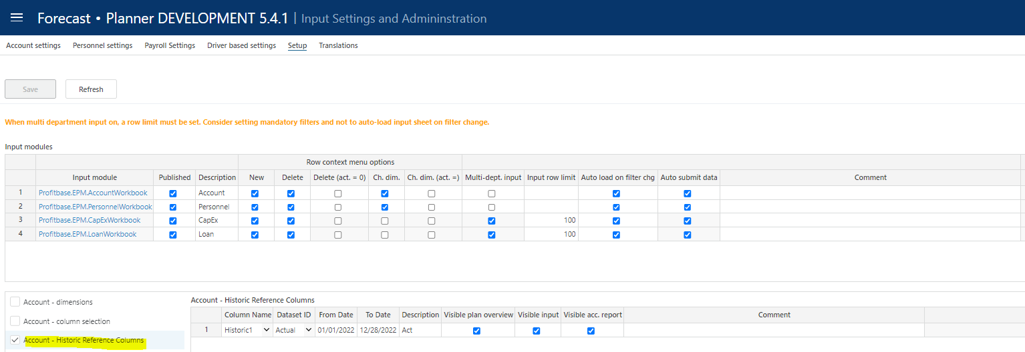

Note that the account module will use the historic ledger (data store ReportAccountByMonthHistorical) as the basis for historical data so that any data desirable to display as reference data must reside there.

There is a preset number of historical reference columns to choose from.

Column | Description
Column Name | The internal historical reference column id, Historic1, Historic2, Historic3, Historic4 and Historic5. Select from the drop-down list.
DatasetID | The dataset origin for the historical reference data. Select from the drop down list.
From Date | The start date for the historical reference data
To Date | The end date for the historical reference data
ColumnName_Description | The column default name. Translations can be added in the Translations tab.
Visible Summary | Indicates that the column is visible in the summary workbook for the process or not (checked | unchecked)
Visible Account Details | Indicates that the column is visible in the account input worksheet or not (checked | unchecked)
Visible acc. Report | Indicates that the column is also visible in the account details report that is available in the “Supporting Details” pane of the Account input module workbook.

Select, name, and define deviation columns

Select the “Input Settings and Administration” workbook and go to the “Setup” page and select the “Account – deviation columns” table:

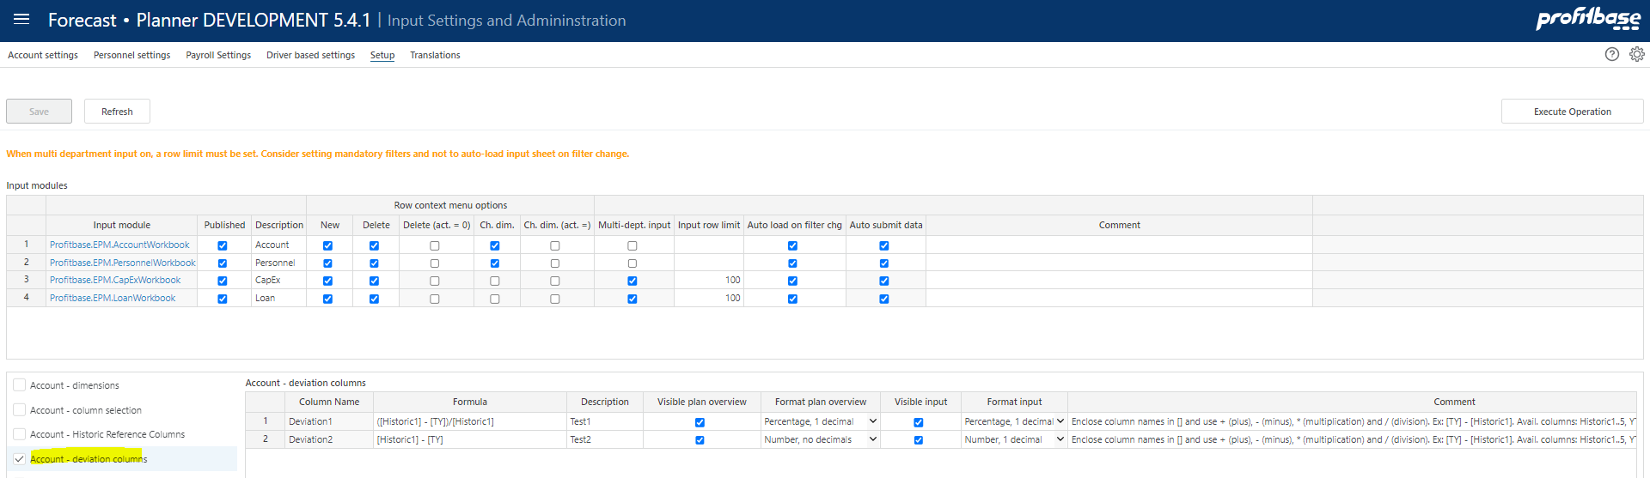

There is a preset number of deviation columns to select.

Column | Description
Column Name | The internal deviation column id, Deviation1, Deviation2.
Formula | See * below
ColumnName_Description | The column’s default name. Translations can be added in the Translations tab.
Visible Plan overview | Indicates that the column is visible in the Plan overview workbook for the process or not (checked | unchecked)
Format plan overview | The number format that the calculated deviation will display in the Plan overview workbook, select from drop down list.
Visible input | Indicates that the column is visible in the account input worksheet and account details report or not (checked | unchecked)
Format input | The number format that the calculated deviation will display in the account input worksheet and account details report, select from drop down list.

*
There are several internal columnids that can be referenced in the formulae:

- Historic1 to Historic5 – historic reference columns, requires that historic reference columns are configured.
- YTD – Year to date (Actuals)
- ROY – Rest of year plan (rest of first plan year, that is from plan start to the end of first plan year)
- TY – This year (first full plan year, comprised of YTD actuals and ROY plan)
- NY – Next year plan (second full plan year)
- L12M – Last 12 months (Actuals)
- N12M – Next 12 months plan (first 12 months of plan)
- NYPlus1 – Third full plan year, requires that long term planning is used.
- NYPlus2 – Fourth full plan year, requires that long term planning is used.
- NYPlus3 – Fifth full plan year, requires that long term planning is used.
- NYPlus4 – Sixth full plan year, requires that long term planning is used.
- NYPlus5 – Seventh full plan year, requires that long term planning is used.

Please note that the internal columnids should be enclosed in [] and that + (plus), - (minus), * (multiplication) and / (division) mathematical operators can be used, for example:

- [NY] – [TY]

If, for example the deviation column is to show This year’s budget – Last year’s budget, and the two are stored in columns Historic1 and Historic2 respectively, the formula would be:

- [Historic1] – [Historic2]

Please Note also that YTD and ROY are not available in the account details report.

Select / unselect optional columns
A set of columns are optional related to actuals last 12 months, year to date and plan rest of year. The columns can be named (default name, refer to Translations for translations) and selected / unselected individually for the plan overview (summary) and account input module respectively:

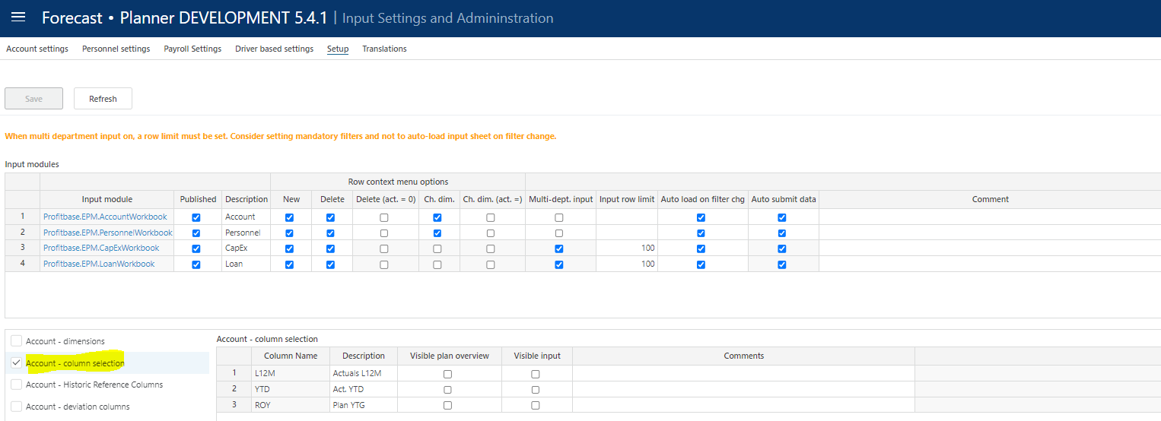

Translations

Translations are added in the Translations tab.

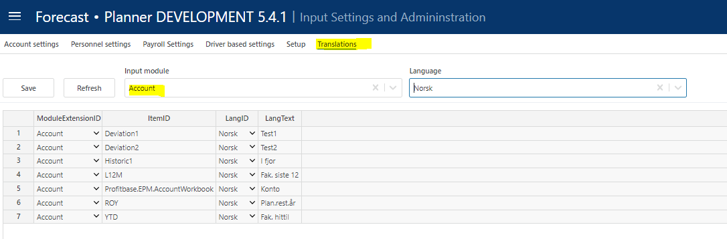

Select Account as the Input module and the language of choice.

Edit the Lang Text column of an item or add an item. The available ItemID are typically the various column ids such as Deviation1, etc.

Attach module to input report

The Account module is the default module and will be attached to any report line that is not specifically attached to another (not the Account) module.

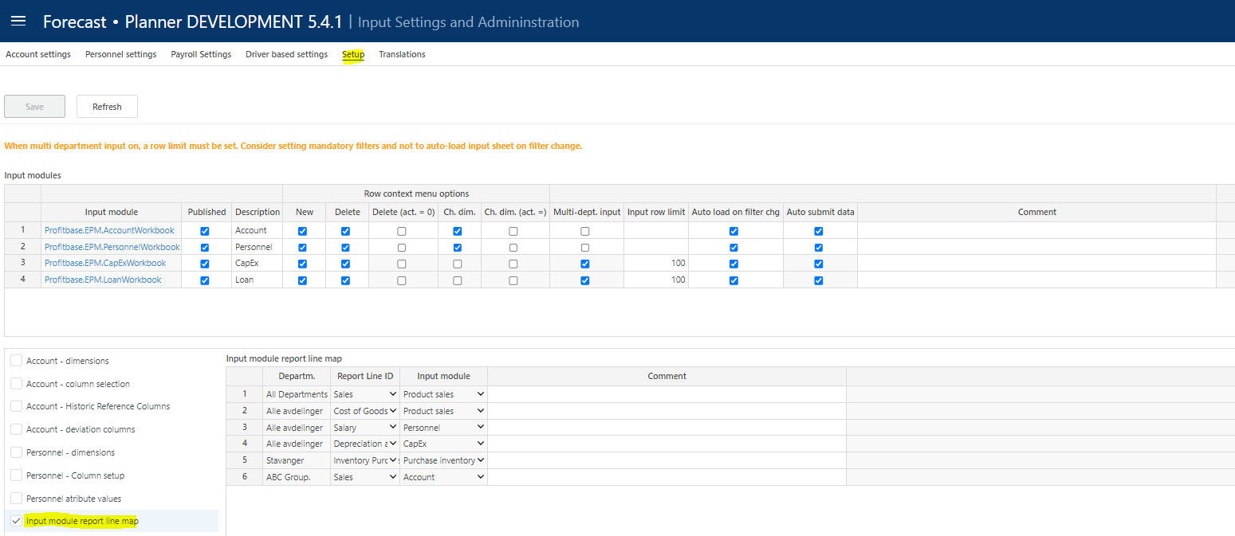

Period filters

The input module contains a period filter in which (time) periods can be selected. The content of this filter can be configured in the “Period filters” table found in the “Setup” page in the “Input Settings and Administration” workbook:

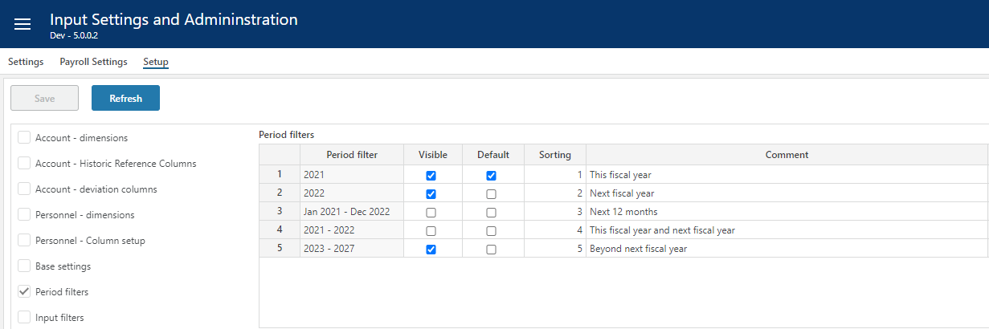

Note that this configuration is global to all input module workbooks and the “Plan Overview” workbook.

Column | Description
Period filter | Available filters, preset.
Visible | Makes filter visible (checked) or not visible (unchecked)
Default | Makes it the default period filter
Sorting | Controls the sorting in the filter drop down
Comment | Optional comment

Disabling the Periods button

By default, the user can toggle between (year) total and (month) periodic input using the Periods button.

In certain cases, it may be desirable to disable the Periods button, leaving the user with the (year) total input option*.

This can be configured in the “Distributed Input Settings” table found in the “Setup” page in the “Input Settings and Administration” workbook by setting the values DISABLED for the setting “AccountPeriodsButton”:

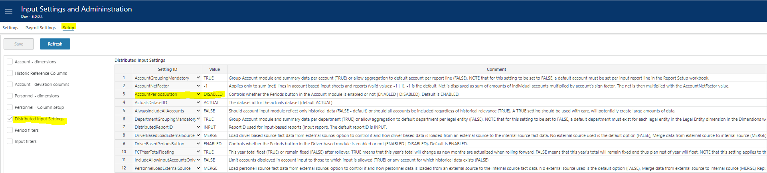

*Note: if the objective is to only allow for (year) total input, the period filter for next 12 months cannot be set as this option only supports periodic (month) input.

Module settings

For account module settings, go to the “Input Settings and Administration” workbook and select “Settings” page.

Distribution keys
Distribution keys are specified by the combination of the department and account dimensions.

The dimensional values are selected using the ranked input selector. For details on using the ranked input selector and making rank changes between rows, please refer to Common functionality for details.

As a general rule-of-thumb, it is advisable not to use too specific distribution keys. Making a high(er)-level selection(s) instead and using aggregate distribution key values relevant to the selection, with the aid of the Distribution key helper where applicable, may be a good starting point.

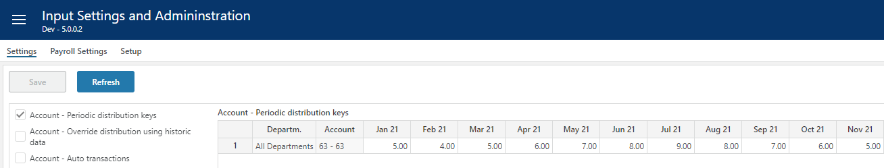

Column | Description
Department | Ranked input. Mandatory
Account | Ranked input. Mandatory.
Monthly distribution key weight (heading dynamic) | Numeric values. Mandatory.  When distributing a year-total value over monthly periods, the weight given to a specific month is its distribution key weight divided by the sum of the distribution key weights for all the months for that year.
Comments | Optional comment. Note that if a comment is added, the contributor will see the comment when viewing the distribution key of an input row.

Distribution key helper

A distribution key helper can be used by clicking the “View Historic Distribution” button. This will display a pop-up in which the distribution of historical data can be viewed.

Make selections in the filter-row at the top and click the “Refresh” button to see the results:

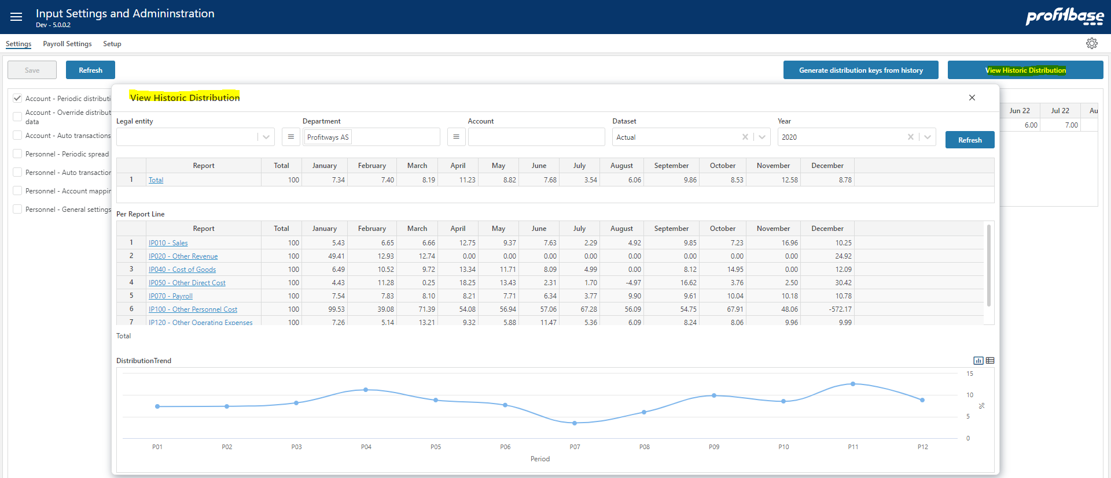

In some cases, it may be relevant to use historic distributions as the basis for future distributions.

If so, copy out the monthly values of a specific row (select cells and click Ctrl-C) and paste into a relevant row in the “Distribution keys” table.

A high-level selection in the Legal entity and/or Department and Account dimensions will display an aggregate distribution over the historical period selected.

Override distribution using historic data
It is possible to override the defined distribution keys described above by using historic data.

This allows for the distribution inherent in a certain time-range of historic transactions for selected department and account combinations to be used as distribution keys. This may be relevant in some cases where historical distribution is expected to recur in the future.

Care should be taken not to use this functionality on too wide a range of departments and accounts as this will generate a potentially large number of very specific distribution keys. Keep also in mind that the user will always be able to input amounts by month for any department and account combination and thereby effectively override any historical keys generated for that combination.

Define the selection of departments and accounts:

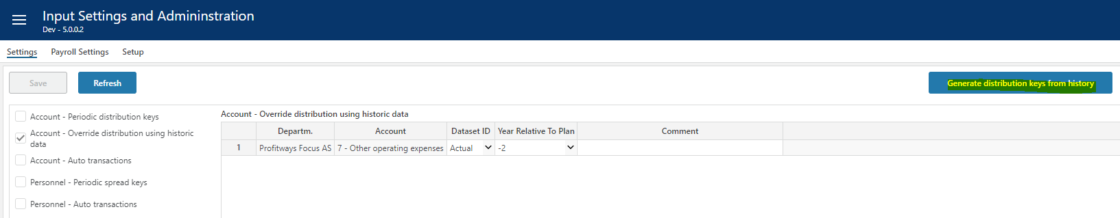

When defined, click the “Generate distribution keys from history” button to generate the keys.

Column | Description
Departm. | Ranked input. Mandatory
Account | Ranked input. Mandatory.
Dataset ID | The historic dataset from which the historic distribution keys are generated. Select from list.
Year relative to plan | Define the time-range for the historical period from which to generate the historic distribution keys.  Numeric values. Mandatory. Select from list.
Comments | Optional comment. Note that if a comment is added, the contributor will see the comment when viewing the distribution key of an input row.

Auto transactions (optional)
Auto-transactions may be used to trigger additional transactions based on user input. For example, the input to a certain account should always generate an additional transaction to another account amounting to 10% of the input or source transaction.

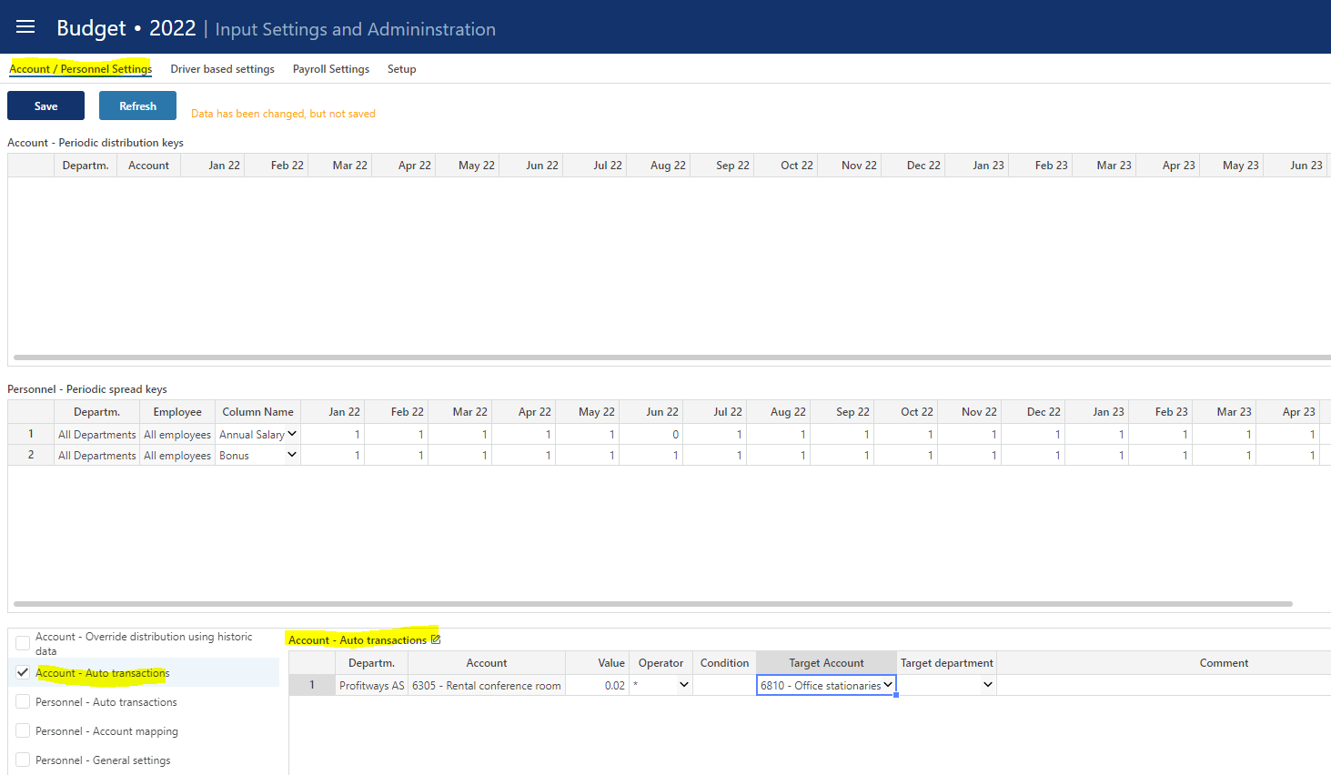

Column | Description
Departm. | Source department. Ranked input. Mandatory
Account | Source account. Ranked input. Mandatory.
Value | The value and the operator define how the amount of the target transaction will be calculated. In the example above, the amount of the target transaction will be 10% of the source amount.  Numeric value. Mandatory.
Operator | Select from list. Mandatory.
Condition | Optional. Special condition to apply when validating whether to execute the rule or not.  For example:  - Month() > 6 indicating that rule will be executed only for transactions with a transaction date with month number greater than 6 (June)  - CurrentPeriodValue() > 1000 indicating that rule will be executed if value currently processed is greater than 1000  Operators:  - Equality: ==  - Greater than or equal to: >= Greater than: >  - Less than or equal to: <= Less than: <  - Logical and: &&  - Logical or: ||
Target Account | Mandatory. The account that the target transaction will have. Select from list.
Target department | Optional. Leave empty if target department should equal the source department. Select from drop down is target department should differ from source department

High level planning with the account module

Profitbase Planner allows planning at the leaf (lowest) levels of the involved dimensions involved.

To plan at a higher level with the account module, default values dimensional values can be used so that historical reference data is aggregated over fewer dimensional combinations.

This is controlled in the dimension settings, using the “Group source data” option. The fewer dimensions have the “group source data” checked, the more aggregated the historical reference data:

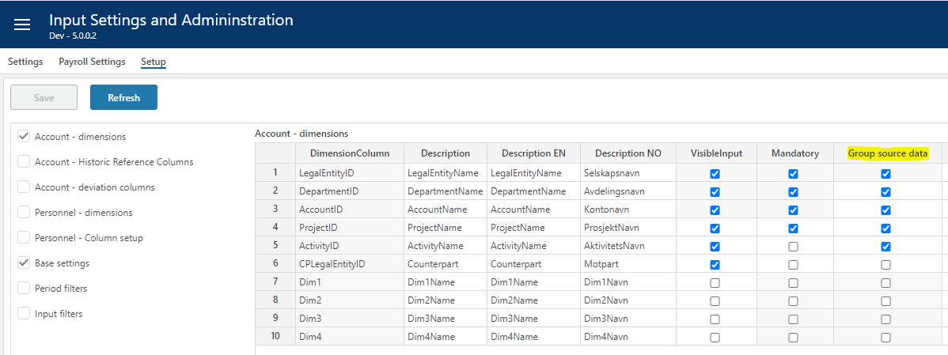

For the optional dimensions, Project, Activity and so on, the default (none) dimensional value is found automatically.

For the Department and Account dimensions, the following has to be set up:

In the “Base settings” table, the following options have to be set to FALSE in order to allow to uncheck “Group source data” for one or both of these dimensions:

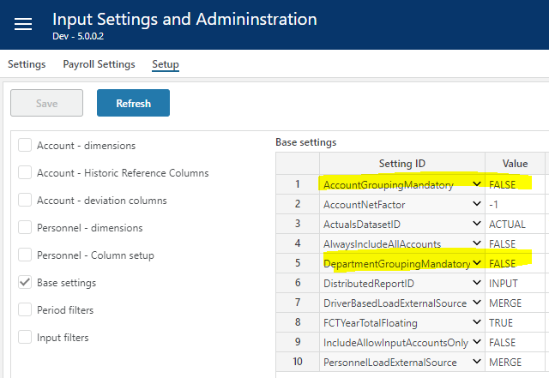

In addition, default values must be provided:

A default account per report line in the INPUT report must be defined. This is done in the “Report Setup” workbook:

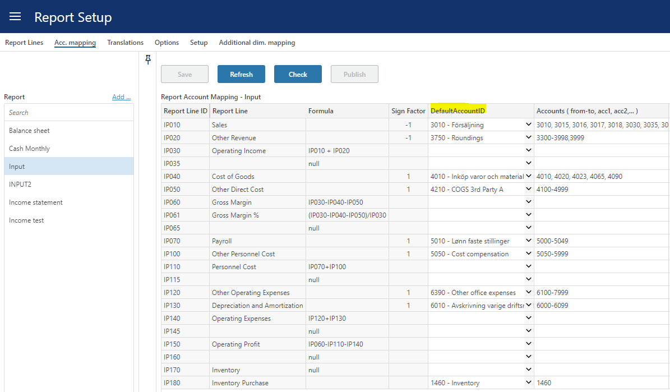

A default department must be defined for each legal entity. This is done in the “Dimensions” workbook, selecting the Legal entity dimension:

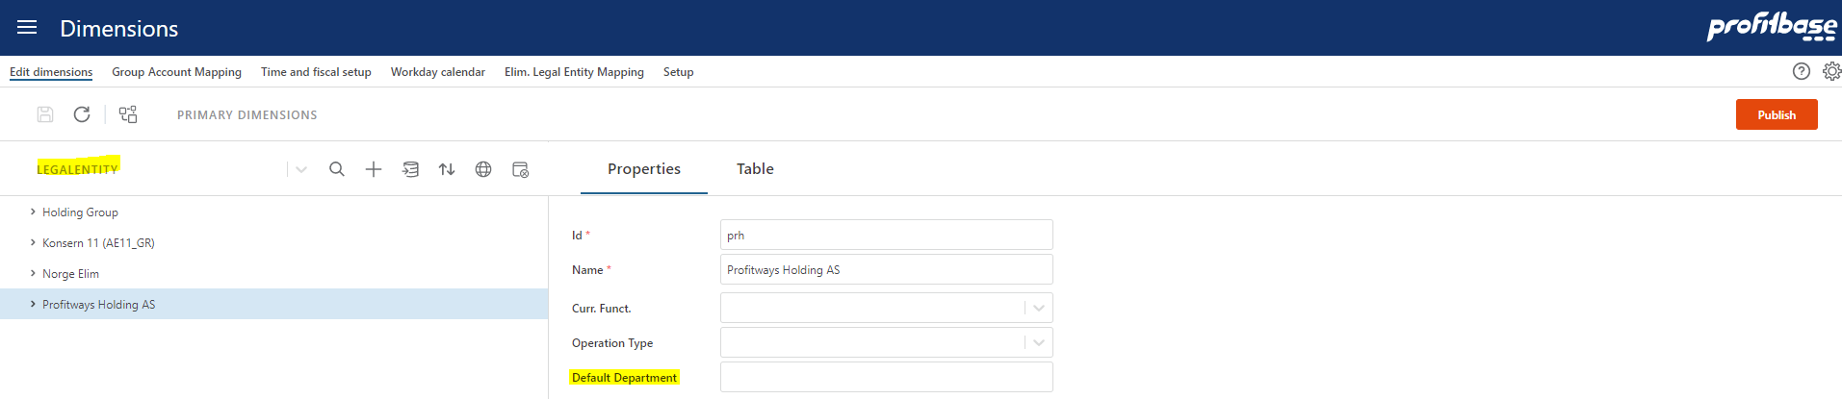

Historical source data will be aggregated to the default account set up per report line and to the default department per legal entity. This applies to both the “Plan Overview” workbook and the account module.

Note, that despite this aggregation, it is still possible to detail the plan by adding new rows and selecting other dimensional members, but it allows for a compact plan from the outset, for example when planning long term and do not require details at every level.

All the other modules can also be used if required.

